Final Project - Phase II
Golan Regional Council Management Application
By Guy Edri & Eldad Shneor
Advisor: Dr. Naomi Unkelos Shpigel
Software Engineering Department
Braude College of Engineering
Project Code: 24-2-D-17
Project GitHub link

Table of Contents
Abstract 2
1. Introduction 3
2. Literature Review 5
2.1. Multi-Year Infrastructure Development (MYID) 5
2.2. Data-Driven Rural Management 5
2.3. Smart Villages and Digital Transformation 6
2.4. Rural Development Index and Evaluation Methods 6
2.5. User centered design 7
3. Engineering Process 8
3.1. Design Process 8
3.2. System Architecture Overview 9
3.2.1. Architecture Diagram 9
3.3. Technologies Review 10
3.3.1. Client Side 10
3.3.2. Server Side 12
3.4. Mobile First Approach 13
4. Work Artifacts 13
4.1. System Requirements 13
4.1.1. Functional Requirements 13
4.1.2. Non-Functional Requirements 14
4.2. Use-Case Diagram 15
4.3. Activity Diagrams 16
4.3.1. General Flow 16
4.3.2. Settlement Data Flow 17
4.3.3. Project Progress 18
4.4. Working Flow Diagram 19
5. User Guide 20
7. Evaluation 34
9. References 45
10. Appendices 46

Abstract
The Golan Regional Council Management Application represents a comprehensive digital solution designed to address the inefficiencies in rural management processes within the Golan Heights regional government. This project transforms the council's fragmented, file-based approach—previously reliant on scattered Excel and Word documents—into a centralized, user-friendly platform that integrates data across all 33 settlements under the council's jurisdiction. The application features dynamic dashboards for real-time visualization of project data, integrated project management capabilities, and settlement-specific data profiles that enable evidence-based decision making.
The core project management functionality allows administrators to create, assign, and track projects through customizable workflows, with milestone tracking, dependency management, and automated notification systems. Project stakeholders can access detailed timeline views, resource allocation metrics, and status reports tailored to their specific role permissions. The system's collaborative features enable real-time document sharing, approval processes, and interdepartmental coordination through unified communication channels. Through modern web technologies including Next.js, Zustand, and PostgreSQL, the solution enables council staff to effectively monitor projects, track infrastructure development across multiple concurrent initiatives, compare settlement metrics, and facilitate the strategic allocation of resources based on comprehensive data analysis.

Introduction
The Golan Regional Council, situated in the Golan Heights, northeastern of Israel, oversees the management of 33 towns[18]. Council employees are tasked with efficiently monitoring and managing various projects and processes within the council's jurisdiction.
A critical aspect of this management involves comparing data across different towns. However, the current system, relying on multiple Excel and Word files, has proven inefficient. This inefficiency stems from the cumbersome nature of handling numerous separate files, each containing data for individual towns. Employees must navigate through these files to gather information, a process that is time-consuming and prone to errors.
The lack of a centralized database makes it challenging to obtain a comprehensive overview of projects and processes across all towns simultaneously. Furthermore, the manual data entry required for each file increases the risk of inconsistencies and outdated information.
Comparing data between towns and projects becomes a laborious task, often requiring staff to open multiple documents side by side, manually extract relevant information, and compile it for analysis. This not only slows down decision-making processes but also increases the likelihood of overlooking crucial details. The system's limitations in facilitating real-time updates and collaborative editing further exacerbate these issues, potentially leading to miscommunication and inefficient resource allocation.
As the council strives to effectively manage its diverse array of towns and many projects it handles, the need for a more integrated and streamlined data management solution becomes increasingly apparent.​​​​​​​​​​​​​​​​
The council has developed a comprehensive plan called PITARON. This five-year infrastructure development initiative aims to systematically enhance the Golan Heights' various facilities and services. Under this plan, each of the 33 villages within the council's jurisdiction is evaluated based on a diverse set of criteria. These evaluations result in calculated scores that reflect the condition of each village across different aspects, such as the state of community buildings, sewage systems, and other critical infrastructure components. Currently, these scores are stored in individual case files for each village, typically in the form of Word and Excel documents.
When new infrastructure projects are proposed or initiated, the details are recorded in a separate Excel file that houses comprehensive project information. This file consists of multiple sheets, each containing data for different departments, with a notable limitation that updating information in one field does not automatically refresh related data across other sheets. This comprehensive dataset is essential for the council's effective management of projects and budgets, serving as the primary repository for critical decision-making information.​​​​ However, the current file-based system for storing and accessing this vital information presents significant challenges in efficiently managing and utilizing this data for strategic decision-making.​​​​​​​​​​​​​​​​
Based on our second meeting, four main requirements were identified as a shift in direction from Phase A.
- Update the "Pitaron" program booklet according to established criteria.
- Provide a tool to handle project management within the council.
- Aggregate council information from various sources to facilitate access to government resources
- Establish a unified data management framework that facilitates seamless information exchange and collaboration across all council departments.
These requirements guide our development of a tailored solution to address the Golan Regional Council's rural management challenges.
This project aims to develop an advanced management system that significantly streamlines data visualization and project management. The proposed system will enable council employees to view data in a simplified and more efficient manner, easily initiate new projects in their designated departments, effectively plan and monitor ongoing projects and strategize for future initiatives. By implementing this digital solution, the Golan Regional Council seeks to enhance its operational efficiency, improve decision-making processes, and ultimately provide better service to the communities under its purview.

Literature Review
  - Multi-Year Infrastructure Development (MYID)
MYID is a comprehensive five-year strategy aimed at transforming rural areas by addressing a wide array of infrastructure challenges. This initiative prioritizes the enhancement of economic, social, security, and housing infrastructure, all designed to improve the quality of life for rural populations across the country. Drawing inspiration from the decentralization efforts in Ukraine [2], MYID seeks to foster regional autonomy while ensuring that national resources are allocated effectively at the local level.
Decentralization in Ukraine, as outlined by Davydenko et al. [2], demonstrates the potential of such strategies in rural development. Ukraine’s decentralization reforms, initiated to address regional disparities and inefficiencies in public service delivery, provide valuable lessons for MYID’s approach. By devolving fiscal and administrative powers to local governments, Ukraine aimed to empower rural communities to address their unique infrastructure needs more effectively, leading to a slowdown in rural population decline and a stabilization of rural employment rates. Similarly, MYID emphasizes local leadership in decision-making, ensuring that projects are tailored to the specific needs of each region, while benefiting from centralized coordination and funding.
Furthermore, the MYID strategy aligns with the concept of decentralization by focusing on the diversification of economic activities in rural areas, creating sustainable employment opportunities, and improving access to essential services such as healthcare, education, and transportation. Drawing from the successes and challenges faced in Ukraine, MYID aims to create resilient rural communities by ensuring that infrastructure development is not only top-down but also responsive to the grassroots level. By fostering local autonomy and encouraging active participation from rural residents, MYID intends to bridge the gap between rural and urban areas, reduce economic disparities, and support long-term sustainability in rural regions.

Data-Driven Rural Management
The shift towards data-driven management in rural areas is becoming increasingly prevalent, representing a significant evolution in rural development strategies. While not explicitly mentioned in the Golan plan, such approaches, as explored by Cheng et al. [1], could potentially enhance the effectiveness of planning and development. These methods facilitate more informed decision-making and resource allocation in rural development projects.
Cheng et al. [1] propose a 7-layer framework for data integration in rural planning, addressing the challenges of distributed, multi-semantic, and multi-source data typical in rural contexts. This architecture enables the creation of a comprehensive data ecosystem that can support various aspects of rural management. It incorporates both data warehouse and real-time data integration methods, allowing for efficient handling of both stable, frequently accessed data and rapidly changing planning data. The integration of Geographic Information Systems (GIS) with Management Information Systems (MIS) is a crucial aspect, allowing for spatial analysis of socio-economic data and enhancing the understanding of rural dynamics.
The benefits of this data-driven approach in rural development are numerous. It enhances decision-making by providing comprehensive, up-to-date data, allowing rural planners and managers to make more informed decisions based on empirical evidence. This leads to more efficient resource allocation, improved monitoring and evaluation of projects, and support for long-term strategic planning. Additionally, centralized data systems can enhance transparency in rural development processes, potentially increasing trust and participation from rural communities.
However, implementing such systems is not without challenges. Ensuring data quality and reliability, particularly in areas with limited technological infrastructure, remains a significant hurdle. There's also the need to bridge the digital divide in rural areas and build capacity at all levels to effectively use and interpret the data. Moreover, while data-driven approaches offer many benefits, they should be balanced with and informed by local, traditional knowledge and practices in rural areas. By carefully addressing these challenges, data-driven rural management approaches could significantly enhance the effectiveness of rural development initiatives.

Smart Villages and Digital Transformation
The concept of Smart Villages has emerged as a key strategy for rural development. Zavratnik et al. [8] conducted a comprehensive review of Smart Village initiatives and digital transformation practices in rural areas. Their study emphasizes the importance of integrating local knowledge with digital innovations to address specific regional challenges and promote sustainable development.

Rural Development Index and Evaluation Methods
To assess and prioritize development needs, a plan was developed that incorporates a scoring system similar to Rural Development Indices used in other countries. For instance, Davydenko et al. [2] used a Rural Development Index based on 14 indicators across economic, social, infrastructural, demographic, and employment dimensions. The Golan plan similarly considers factors such as population size, existing infrastructure, and specific community needs in its evaluation process [7]. This comprehensive approach aligns with the multi-dimensional nature of rural development, as highlighted in the Ukrainian study.

User centered design
User-Centered Design (UCD) is a critical methodology for enhancing the effectiveness and efficiency of digital transformation efforts, especially in public services. A case study in Brazil [3] illustrates how UCD, by focusing on citizen involvement, can significantly improve the delivery and usability of digital services. The study applied UCD techniques through participatory design workshops, incorporating methods such as ethnography and design thinking, to address the needs of the Call-100 service, a hotline for reporting human rights violations. By involving users directly in the design process, the approach fostered a deeper understanding of the real challenges and expectations that citizens face when interacting with public services.
The findings of the study indicate that UCD leads to higher user engagement and awareness, as well as greater system efficiency and satisfaction among users. In particular, the inclusion of citizens in workshops helped generate practical solutions that reduced the complexity of interactions, minimized redundant processes, and ultimately lowered operational costs. Furthermore, UCD ensured that the digital channels provided by the government aligned more closely with user needs, offering improved accessibility and a more humanized user experience. This process not only motivated citizens to be more active participants in public services but also allowed the government to make better-informed decisions based on direct feedback from the population.
The success of UCD in this context underscores its importance in ensuring that technological solutions in the public sector are not only efficient but also user-friendly and responsive to real-world demands. This citizen-centered approach is crucial for building trust, improving the quality of digital services, and ensuring that public investments in technology genuinely enhance the well-being of citizens.
​

Engineering Process

Design Process
Our design process for the Golan Regional Council Management application followed a user-centered, iterative approach that involved several key stages:
- Requirements Gathering: We began with comprehensive stakeholder interviews, including a key meeting on July 15, 2024, with council management. This helped us identify the core needs and pain points in the current system, such as the lack of a unified platform for planning and data presentation.
- Research and Analysis: We conducted a thorough literature review, examining academic journals, industry publications, and case studies related to rural management systems. This research informed our understanding of best practices and innovative solutions in the field.
- Conceptualization: Based on the gathered requirements and research insights, we developed initial concepts for the system architecture. We focused on addressing the four main objectives that were brought up in the Interview.
- Technology Selection: We carefully evaluated various technologies, ultimately selecting a stack that includes Next.js, Zustand, and Auth.js. This selection was based on the need for performance, development friendly, and alignment with modern development practices.
- Mobile-First Design: Recognizing the increasing importance of mobile access, we adopted a mobile-first design approach. This ensured that the application would be fully functional and user-friendly on smaller devices while scaling effectively to larger screens.
- Prototyping: In the final stage of our design process, we concentrated on developing visual representations of the system's architecture and user interface. This crucial step transforms our conceptual ideas into concrete designs, allowing stakeholders to interact with and evaluate the proposed system.

System Architecture Overview
This system architecture describes a modern web application built using Next.js 15 as the core framework, providing a unified platform for both client-side and server-side development. On the client side, the application leverages React components styled with Tailwind CSS and enhanced by Shadcn/UI for a polished user interface. State management is handled by Zustand, offering a lightweight and flexible solution. The application is primarily written in TypeScript and JavaScript, ensuring type safety and improved developer experience.
User authentication and authorization are managed through Kinde, providing secure access control. On the server side, Next.js 15 continues to play a central role, facilitating API routes and Server Actions for data operations. The backend is powered by Neon.tech, a robust PostgreSQL-based database framework, enabling efficient data storage and retrieval. This architecture combines cutting-edge technologies to create a scalable, performant, and developer-friendly web application stack.

Architecture Diagram
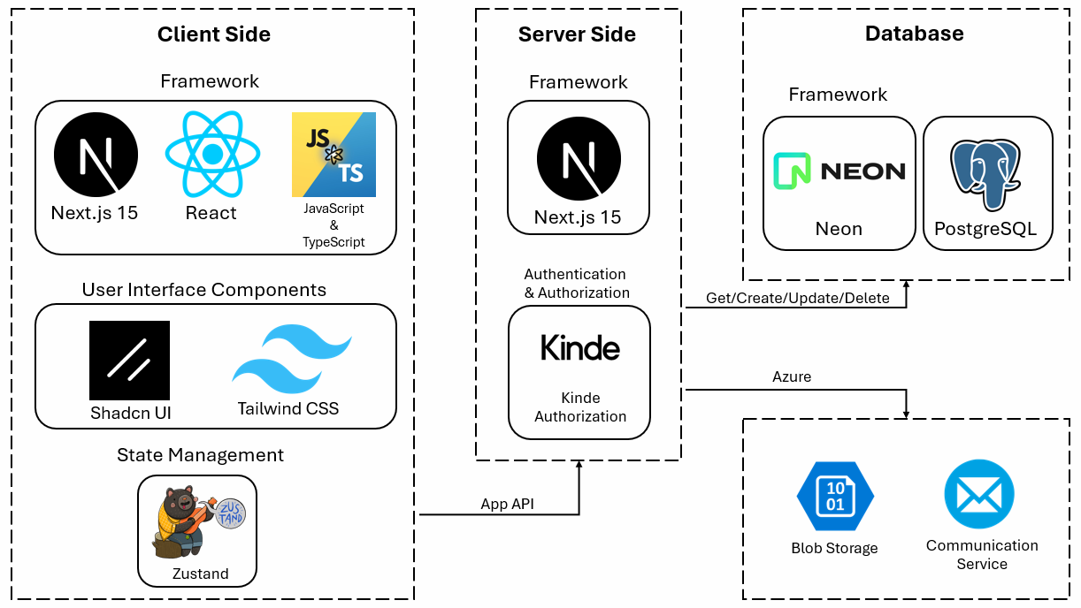
Figure 1. Architecture Diagram

Technologies Review

Client Side

Next.JS is a React framework that provides a robust set of features for building modern web applications. It offers server-side rendering for improved initial page load and SEO, static site generation for blazing-fast static pages, and automatic code splitting for optimal loading performance. Next.js also includes built-in CSS support, optimized asset handling, and API routes for creating serverless functions. Its seamless integration with platforms like Vercel makes deployment a breeze, enabling developers to focus on building great user experiences. [9]

TypeScript extends JavaScript by adding static types, which leads to early error detection during development and improved code readability. It essentially acts as self-documentation for your code, enhancing IDE support with better autocomplete and refactoring tools. This makes it easier to maintain large codebases and ensures compatibility with existing JavaScript code. By catching type-related errors before runtime, TypeScript significantly improves the overall quality and reliability of your application. [10]
      - Tailwind CSS is a utility-first CSS framework that allows for rapid UI development. It provides a comprehensive set of pre-built utility classes that can be composed to create custom designs quickly. Tailwind is highly customizable, allowing you to tailor the design system to your project's needs. It integrates PurgeCSS to minimize production CSS, includes responsive design utilities out of the box, and offers built-in dark mode support. These features combine to make Tailwind an efficient tool for creating polished, responsive user interfaces. [11]
      - Shadcn UI is a collection of reusable UI components built on top of Radix UI and styled with Tailwind CSS. It provides accessible and customizable components that help maintain a consistent design language across your application. Shadcn UI integrates seamlessly with Next.js and Tailwind CSS projects, offering a set of well-designed, ready-to-use components that can significantly speed up development. With regular updates and community support, it's a valuable addition to any modern web development toolkit. [12]
      - Zustand is a minimalistic state management library for React that offers a simple and intuitive API. Unlike more complex state management solutions, Zustand requires no boilerplate code and integrates easily with React hooks. Its small size and efficient update mechanism contribute to great performance. Zustand also includes built-in support for async actions and middleware, making it a flexible choice for managing application state in React projects of various sizes and complexities. [13]

Server Side

Neon is a serverless, fault-tolerant PostgreSQL database platform built for modern cloud applications. It features a unique architecture that separates compute and storage, allowing for automatic scaling and instant branch creation for development and testing. Neon offers a generous free tier, time travel capabilities for point-in-time recovery, and high-performance operation with low latency. Its serverless model eliminates the need for infrastructure management, making it an ideal PostgreSQL solution for developers seeking flexibility, reliability, and cost efficiency. [14]

Kinde is a comprehensive authentication and user management platform designed for web applications. It provides a full suite of authentication methods including social logins, passwordless options, and multi-factor authentication. Kinde features a user-friendly dashboard for managing users, permissions, and roles, along with customizable branding for login interfaces. Its developer-friendly SDKs and APIs make integration straightforward across various frameworks, while built-in security features like bot protection and account recovery workflows ensure robust protection for applications of all sizes. [15]

PostgreSQL is a powerful, open-source object-relational database system that plays a crucial role in our server-side stack. It provides robust data storage with support for complex queries, transactions, and excellent data integrity features. Its ability to handle large amounts of data and concurrent users makes it suitable for applications of various sizes. [16]

Azure Blob Storage is a scalable cloud storage service for unstructured data that serves as our system's file repository. It enables secure storage of user-uploaded files, media assets, and backup data with virtually unlimited capacity. The service integrates with our Next.js server for seamless file operations and provides features like signed URLs for secure access and tiered storage options for cost optimization. Its geo-redundancy capabilities ensure data availability while the pay-per-use model aligns costs with actual usage. [22]

Azure Communication Service is a cloud-based communication service that enables reliable email delivery for applications. It provides transactional email capabilities for account verification, notifications, and marketing communications with features like templates and analytics. The service integrates directly with our Next.js server through APIs and supports event-driven triggers for automated email workflows. Its scalable infrastructure ensures high deliverability rates while maintaining compliance with anti-spam regulations. [23]

Mobile First Approach
The Mobile First approach is a design and development strategy in software engineering that prioritizes creating the mobile version of a website or application before designing for larger screens. This methodology, introduced by Luke Wroblewski in 2009, has gained significant traction due to the increasing prevalence of mobile devices.
Key aspects of the Mobile First approach include:
- Prioritization: Focusing on core content and functionality essential for mobile users.
- Progressive enhancement: Starting with a basic mobile design and progressively adding features for larger screens.
- User-centric design: Addressing mobile users' needs and behaviours from the outset.
- Responsive design: Ensuring seamless adaptation to various screen sizes and devices.
By adopting a Mobile First approach, development teams can create more focused, efficient, and user-friendly applications that cater to the growing mobile user base while still providing a quality experience on larger devices.

Work Artifacts

System Requirements

Functional Requirements
- The system will allow different users to log in with a username and password or log in with google.
- The system will allow varying levels of access to different roles.
- The system will provide an overview of key metrics and statistics related to urban management.
- The system will provide notifications about recent activities.
- The system will allow users to add, edit, and delete data related to each town.
- The system will store and manage data such as population, infrastructure, budget, and ongoing projects.
- The system will allow users to create, edit and delete projects.
- The system will Visualize comparisons using charts and graphs.
- The system will allow to assign projects to different departments and set deadlines.
- The system will provide a progress tracking feature for ongoing projects.
- The system will allow to generate reports based on selected criteria (e.g., town data, project data).
- The system will allow to filter projects based on different parameters (e.g., department, funding sources).
- The system will send notifications and alerts for upcoming deadlines, project updates, and important events.

Non-Functional Requirements
- The application must load within 2 seconds for the main dashboard. - Performance
- The system should handle up to 100 concurrent users without performance degradation. - Performance
- The application should be scalable to accommodate future growth in the number of users and data volume. - Scalability
- The user interface should be intuitive and easy to navigate. - Usability
- Implement automated backups and disaster recovery plans. - Reliability
- The application should be compatible with major web browsers (Chrome, Firefox, Safari, Edge). - Compatibility
- The application should be compatible for both desktop and mobile devices. – Compatibility
- The system will support exporting data to various formats (PDF, XLSX) for compatibility with other systems. – Compatibility

Use-Case Diagram
- User - A regular employee of the Golan regional council with full management access to create, edit, and remove projects within the system. This staff member can access user directories and funding source databases to support cross-departmental collaboration. They also have permissions to view and modify village data records.
- Admin - Can do anything a regular user can do and, in addition, can invite new users to the system.
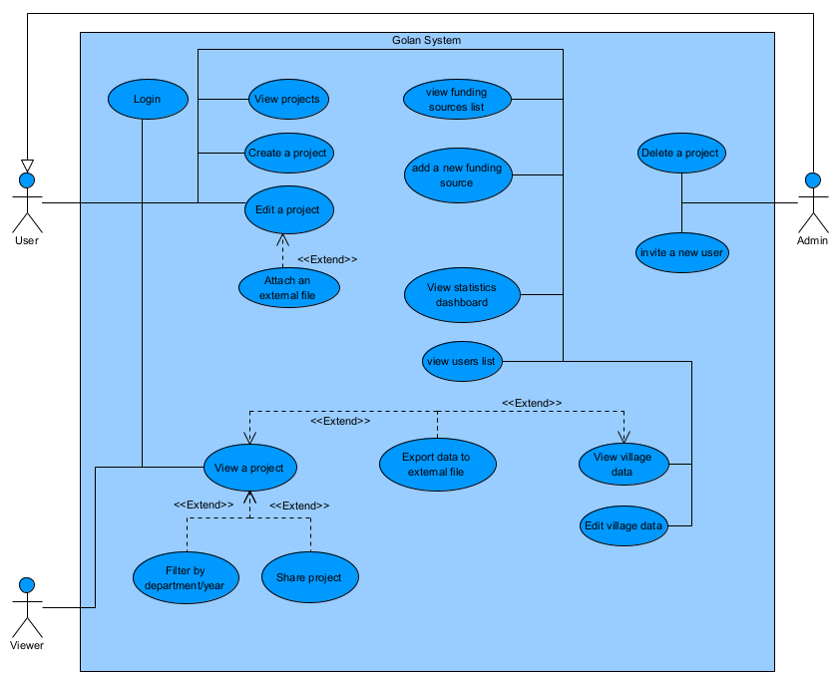
- Viewer - Can see a project’s data without the option to edit it. a viewer is not part of the project’s staff but can see its details.
Figure 2. Use-Case Diagram

Activity Diagrams

General Flow
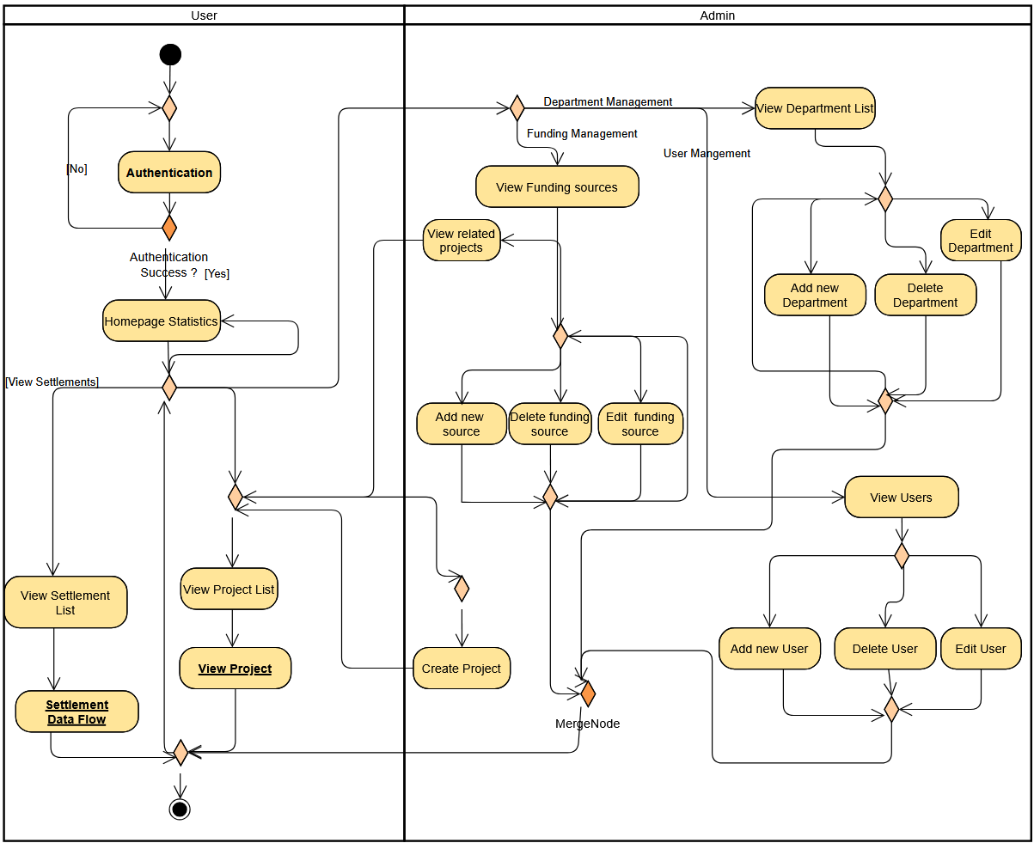
Figure 3. Activity Diagram – General flow

Settlement Data Flow
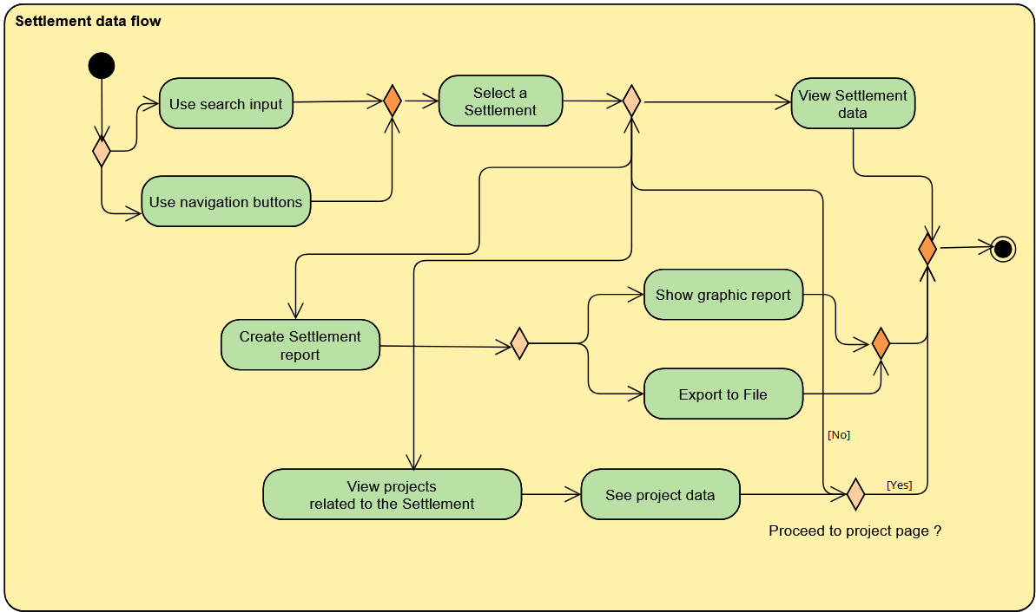
Figure 4. Activity Diagram – Settlement data flow

Project Progress
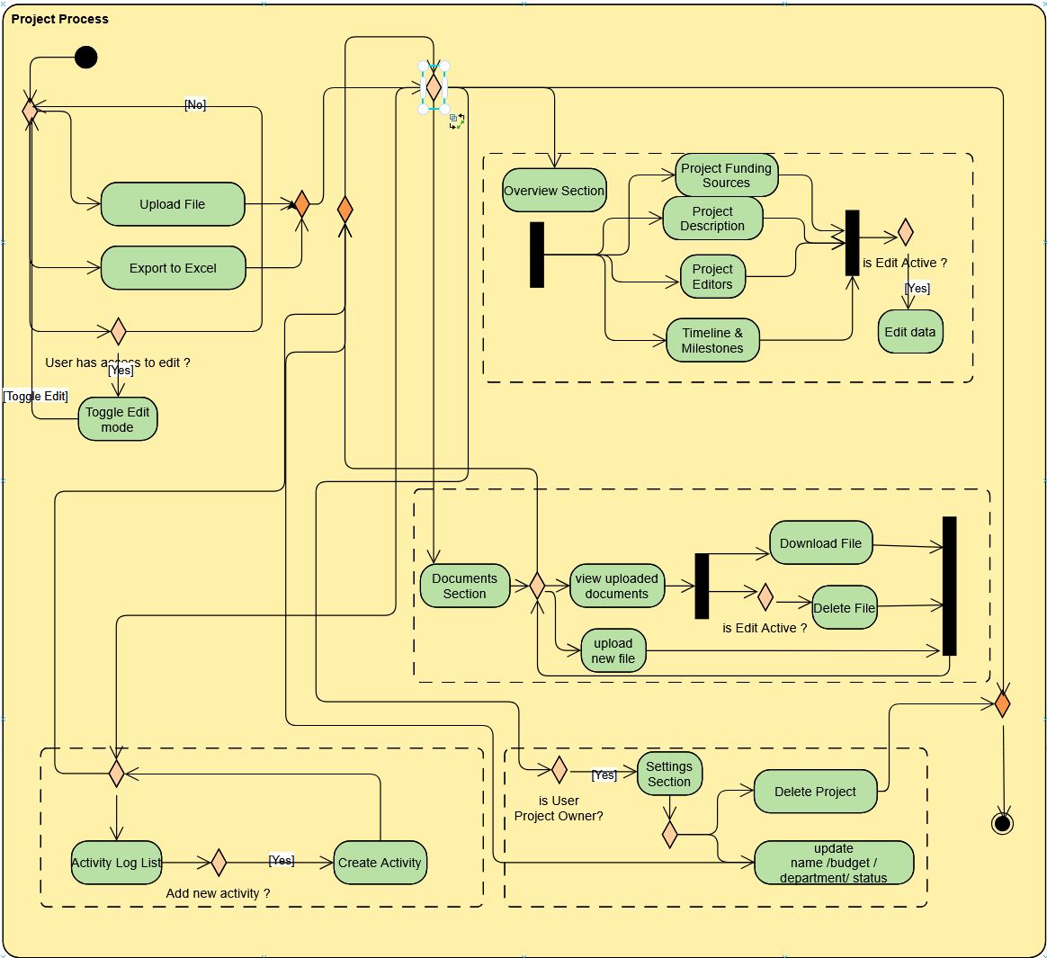
Figure 5. Activity Diagram – Project Process

Working Flow Diagram
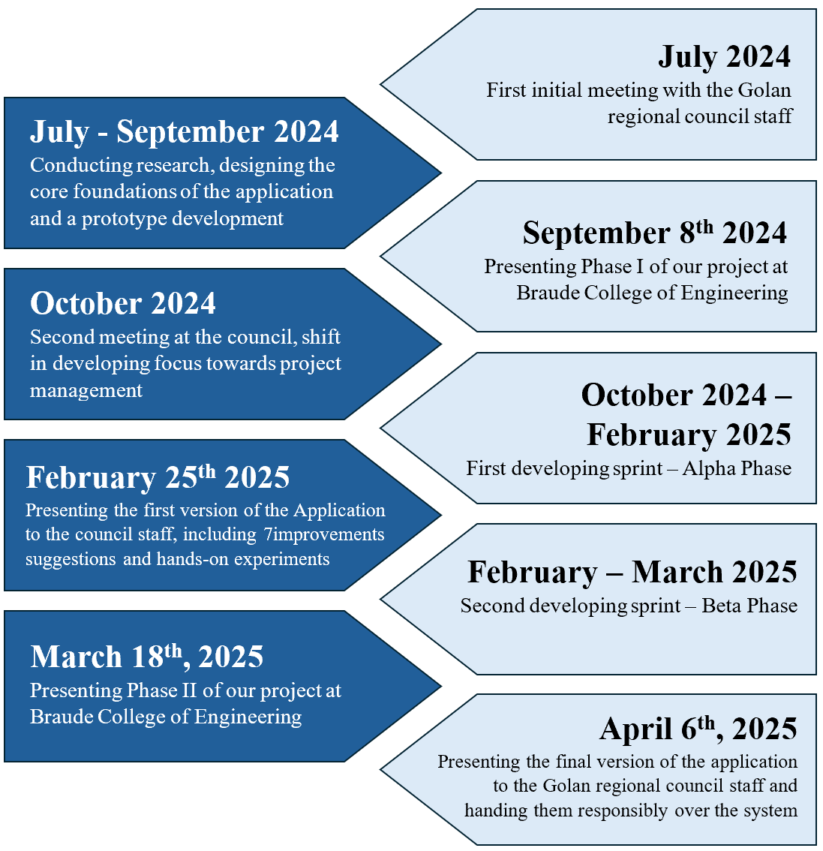
Figure 6. Working Flow Diagram

User Guide
  - WEB
    - Login Page
- Purpose: This login page is designed to provide secure access to the system while offering users multiple convenient login options. The login process is performed via Kinde and is completely passwordlessly, ensuring that users can easily and safely access their accounts. There is no Sign-up option, a new user must be invited by an admin in the system.
- Key Elements:
- Main login field: The central text input field is where you enter your electronic/digital credentials.
- Login button: The black “המשך” button initiates the login process.
- Alternative login option: At the bottom of the page there is a button “המשך עם Google” for logging in using your Google account.
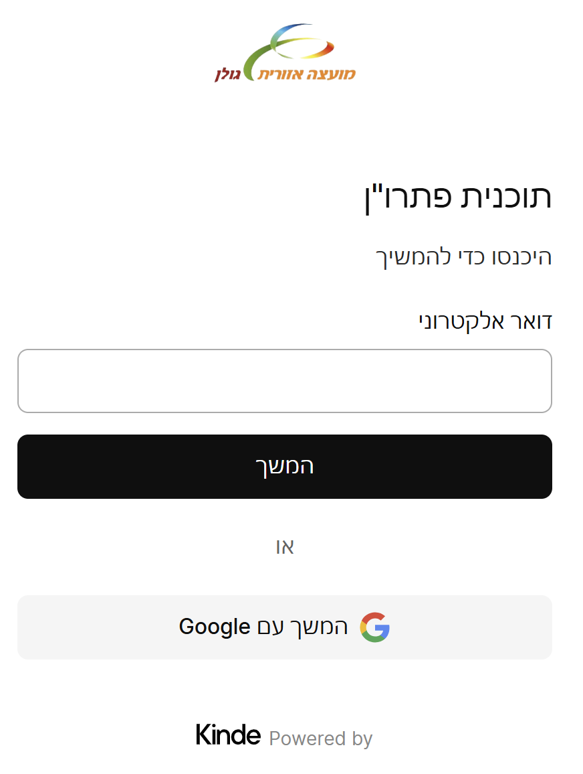
Figure 7. Login screen

    - Sidebar Menu
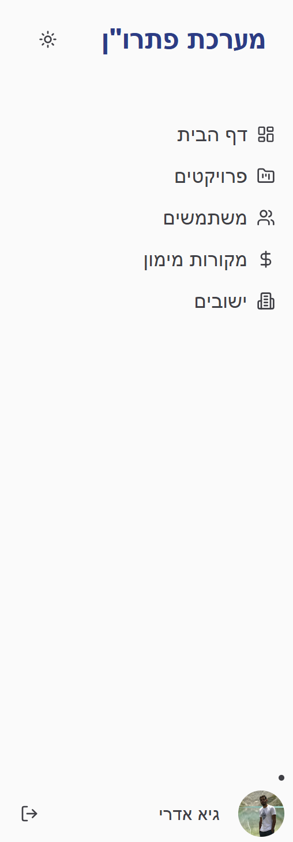
- Purpose: The sidebar menu serves as the primary navigation interface for the platform. It provides quick access to key functional areas of the application, allowing users to efficiently navigate between different sections and features.
Figure 8. Sidebar Menu
      - Key Elements:
- דף הבית: Pressing that will direct the user to the application home page.
- פרויקטים: Pressing that will direct the user to the projects page.
- משתמשים: Pressing that will direct the user to the users list page.
- מקורות מימון: Pressing that will direct the user to the funding resources page.
- ישובים: Pressing that will direct the user to the settlements page.
- User’s info: At the bottom of the screen the user’s name and photo appear, next to a logout button.

    - Home Page
- Purpose: This dashboard provides a comprehensive overview of key organizational metrics and performance indicators. It offers insights into various aspects of the organization's financial and operational status through multiple visualizations and data representations, both from a personal or global perspective.
- Key Elements:
- The number of projects graph: This graph shows how many projects take place in the current year, divided by months.
The user can see the number of projects he is responsible for and the number of total projects that take place in the council.
- Leading funding sources graph: This graph shows the top funding sources in active/in planning projects.
- Projects status graph: This graph shows the distribution of project statuses between active, in planning, delayed and completed.
- Leading departments graph: This graph shows the top departments with the most projects under its responsibility.
- Budget allocation by settlements graph: This graph shows the projects budget distribution between all 33 villages under the council’s jurisdiction.
- Projects near deadline: This list present the 5 projects that are closest to their deadline. Each line in this list is a link that will open the project’s details and an option to go to the project’s page.
- New projects: This list present the 5 newest projects in the system. Each line in this list is a link that will open the project’s details and an option to go to the project’s page.

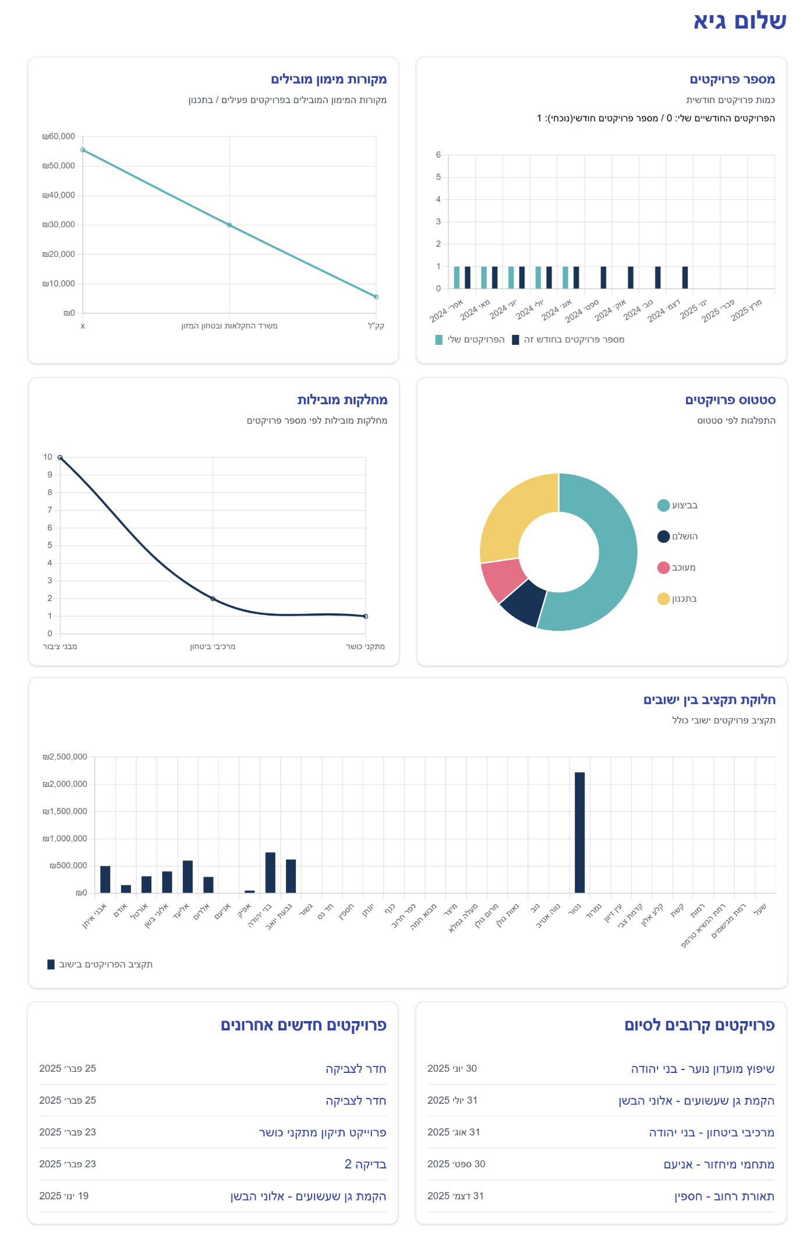
Figure 9. Home Page

    - Projects Page
- Purpose: This projects page provides a comprehensive overview and management interface for tracking various projects within the organization. It offers a structured approach to viewing, filtering, and managing project information.
- Key Elements:
- Top right-side drop menu: This menu allows the user to sort the projects by departments, funding sources or by year.
- Top right-side search box: Allows the user to search values by the sorting method chosen.
- Right-side menu: This menu displays filtering options for projects by department, funding source, and year.
- Top-left left-side menu: a black “צור פרויקט חדש” button to create a new project.
- Top left-side menu: Allows the user to search projects by their name.
- Projects list: This list displays all the projects according to the sort
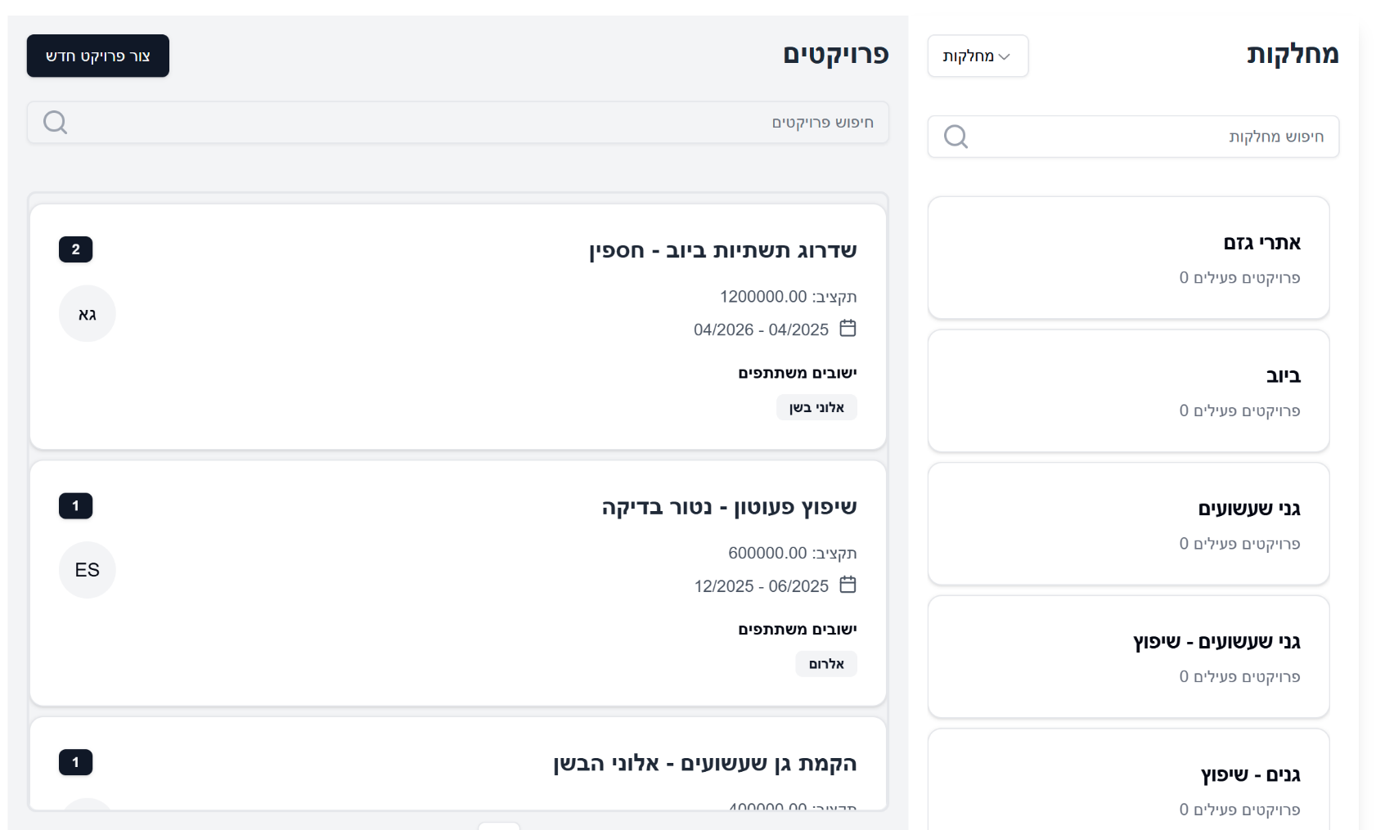
Figure 10. Projects Page
    - Project Page
- Purpose: This detailed project management interface provides comprehensive information and controls for a specific project, allowing users to track, manage, and monitor project progress, budget, and key metrics.
- Key Elements:
- Project main details: The top of the page displays the main details of the project including name, budget, start and end date, department and owner.
- Left side: On the left side of the page the user can edit the project data, add an external file, extract data to an external file, see the milestones accomplishment and recent activity in the project.
- Top tabs: Below the project main details there are 4 tabs for the user to choose according to his interest: “overview”, “documents”, “activity log”, “settings”.
- Overview: Shows the project description, staff members, funding sources and project milestones.
- Documents: Shows the documents attached to the project and allow to attach a new file.
- Activity log: Shows the history of changes in the project data by who performed a change and what the change is.
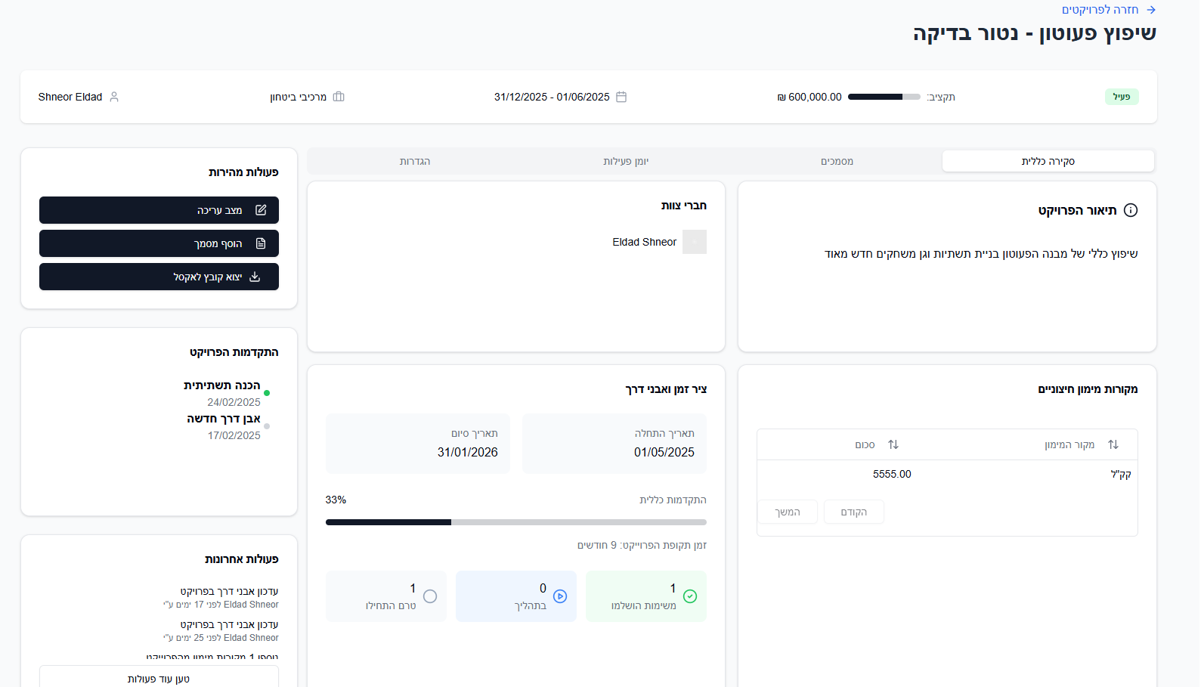
- Settings: Allows the project staff to change its main details (name, budget, department, status) and to delete the project.
Figure 11. Project Page
    - Users Page
- Purpose: The user management page provides a comprehensive overview of system users, allowing administrators to view, manage, and invite new user accounts across the organization.
- Key Elements:
- Top-right: a search box to search for a user by name.
- Top-left: a black button to invite a new user.
- Users list: A list of all the users registered in the system and can perform actions.
- Left-side of the users list: an options button (three dots) that allow editing and deleting users.
- Bottom-left: Navigation buttons to move across list pages.

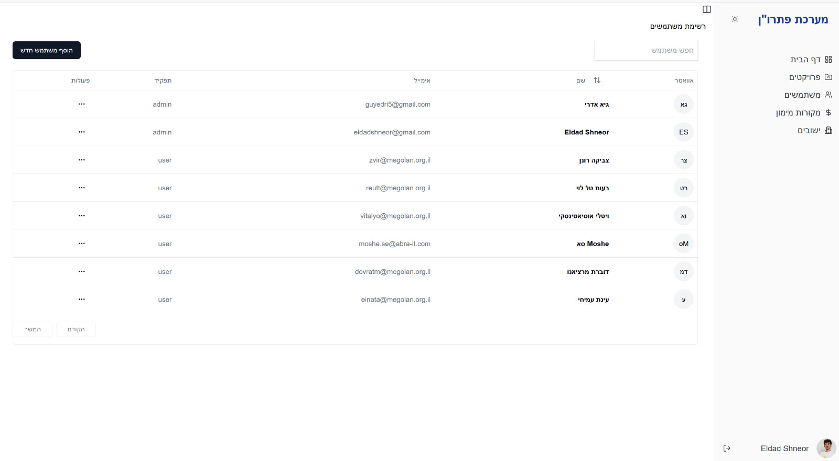
Figure 12. Users Page

    - Funding Sources Page
- Purpose: The funding sources management page provides a comprehensive overview of various financial sources and funding mechanisms supporting the organization's projects and initiatives.
- Key Elements:
- Top-right: a search box to search for a funding source by name.
- Top-left: a black button to add a new funding source.
- Funding source list: A list of all the funding sources registered in the system and can fund projects.
- Left-side of the users list: an options button (three dots) that allow editing, deleting and view projects funded by this source.
- Bottom-left: Navigation buttons to move across list pages.

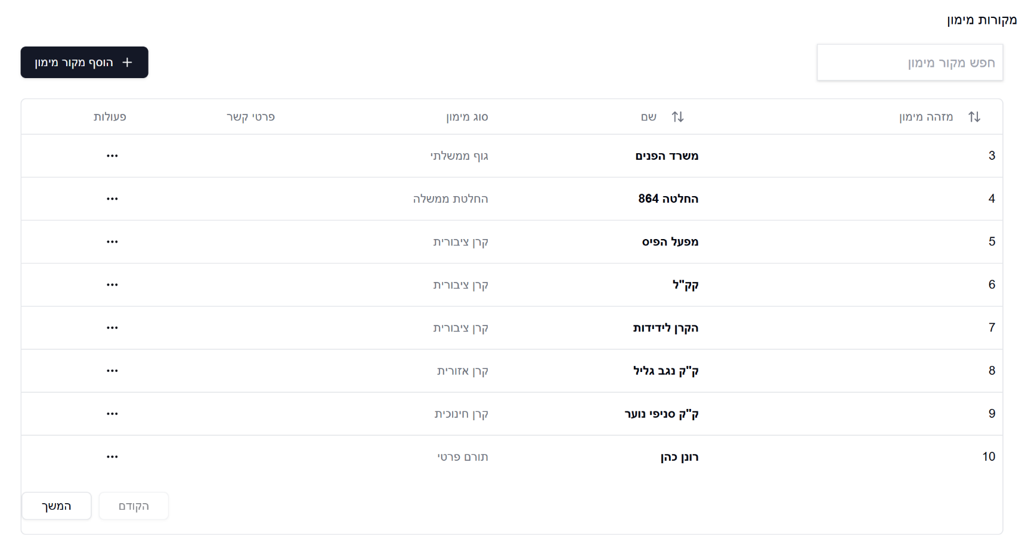
Figure 13. Funding Sources Page
    - Settlements Page
- Purpose: The Settlements list page contains all 33 settlements under the jurisdiction of the Golan regional council. It allows to choose a settlement to view its data.
- Key Elements:
- Top-right: A search box to search for a settlement by name.
- Settlements list: A list of all 33 settlements.
- Bottom-left: Navigation buttons to move across list pages.
- Bottom button: A black button “בחר” to confirm choice and lead to Settlement page.

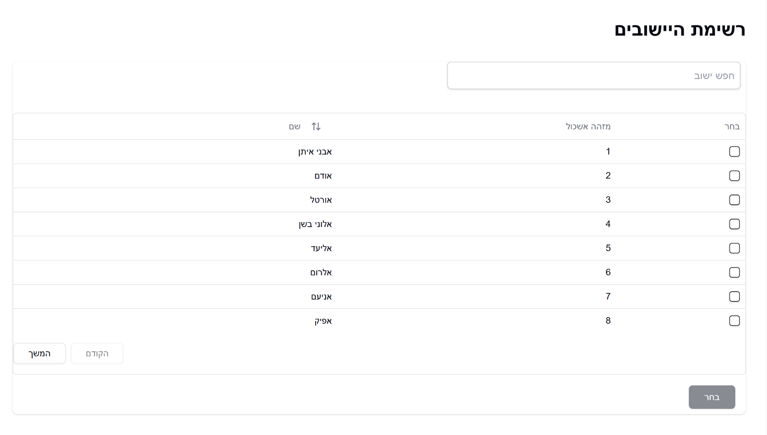
Figure 14. Settlements Page
    - Settlement Page
- Purpose: This comprehensive dashboard provides data and in-depth analysis of a specific settlement, offering key metrics, progress tracking, and strategic insights.
- Key Elements:
  - Settlement main details: The top of the page displays the main details of the settlement including name, population, probable growth rate and probable population by 2030.
- Top-Left: Three black button that allow to edit the data and export the shown data to external files.
- Projects list: Present all the projects that take place in chosen settlement. Each line in this list is a link that will open the project’s details and an option to go to the project’s page.
- Bottom-Right: a list of topics under the settlement management and a list of related projects that affect the settlement.
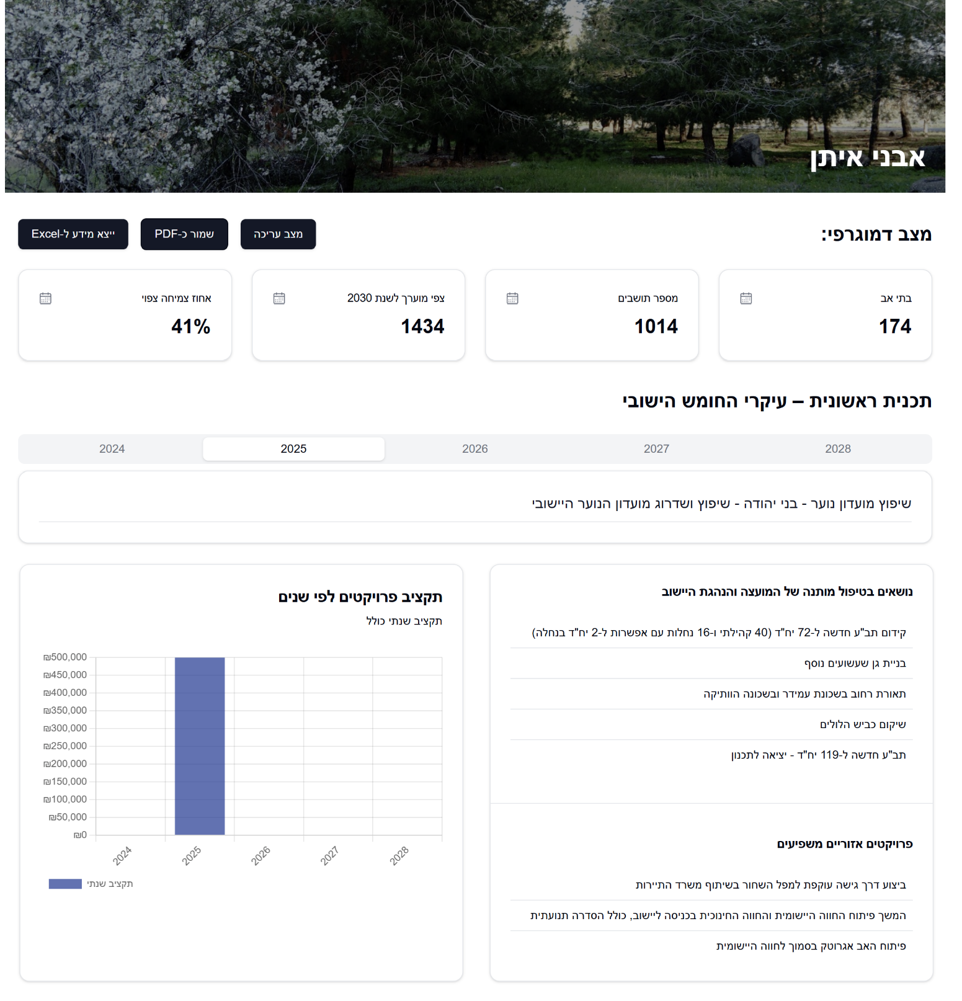
- Bottom-Left: a graph that shows the settlement project budget allocation distributed by year.
Figure 15. Settlements Page

Figure 15. Settlement Page
- Maintenance Guide
  - Required Components:
- Node.js and npm environment (for Next.js framework).
- Kinde account credentials (authentication service).
- Azure subscription (file storage solution).
- Neon PostgreSQL instance (database service).
- Git version control system.
  - Initial Configuration:
    - Obtaining source code:
git clone https://github.com/GuyEdri8/Golan-Project
    - Installing dependencies:
npm install
    - Setting environment variables:
Create a. env.local file in the project's root directory with the following parameters we separated:
Kinde Auth Configuration
KINDE_CLIENT_ID=<your-kinde-client-id>
KINDE_CLIENT_SECRET=<your-kinde-client-secret>
KINDE_MACHINE_ID=<your-kinde-machine-id>
KINDE_MACHINE_SECERT=<your-kinde-machine-secret>
KINDE_ISSUER_URL=<your-kinde-issuer-url>
KINDE_SITE_URL=<your-site-url>
KINDE_POST_LOGOUT_REDIRECT_URL=<your-post-logout-redirect-url>
KINDE_POST_LOGIN_REDIRECT_URL=<your-post-login-redirect-url>
Database Configuration
DATABASE_URL=<your-neon-postgresql-connection-string>
Azure Storage Configuration
AZURE_STORAGE_CONNECTION_STRING=<your-azure-storage-connection-string>
AZURE_STORAGE_ACCOUNT_NAME=<your-azure-storage-account-name>
AZURE_ACCOUNT_KEY=<your-azure-account-key>
AZURE_STORAGE_CONTAINER_NAME=<your-azure-storage-container-name>
Site URL
NEXT_PUBLIC_SITE_URL=<your-site-url>
    - Database setup:
To create the database locale, you need to first generate the tables
npm run db:generate
After creating the database locale, we need to upload it to Neon
npm run db:migrate
    - Running the local environment:
npm run dev
The system will be accessible at: http://localhost:3000
  - Configuration
    - Authentication Settings
The system uses Kinde as an authentication solution. Configure the following parameters in the Kinde dashboard:
      - Application Setup:
- Application type: Back-end web
- Language/framework: NextJS
- Authorized redirect URLs:
`http://localhost:3000/api/auth/kinde/callback` (development),
`https://your-production-domain.com/api/auth/kinde/callback` (production)
- Logout URLs:
`http://localhost:3000` (development),
`https://your-production-domain.com` (production)
- Application type: Machine to machine (M2M)
- APIs Kinde Management API Scopes …
After clicking on the three dots you need to authenticate
- APIs Kinde Management API Scopes
  - create:organization_user_permissions
  - read:organization_user_permissions
  - delete:organization_user_permissions
  - create:users
  - delete:users
  - read:users
  - update:users
      - Permission Setup:
Configure the required permissions for different user roles (admin, manager, user)
      - Azure Storage Settings
Creating a Storage Account:
    - Create a storage account in Azure
    - Create a container for system files
    - Configure public access policy for the container according to security requirements
      - Setting Access Keys:
  - Obtain the connection string and access keys from the Azure dashboard
  - Configure the keys in the environment file
      - Neon PostgreSQL Database Settings
Creating an Instance:
  - Create a PostgreSQL instance on the Neon platform
  - Create a database for the system
Connection Setup:
  - Obtain the connection string from the Neon dashboard
  - Configure the connection string in the environment file
      - Version Management
Updating Versions
The system is based on Next.js and additional dependencies. To update versions:
Update all dependencies to the latest versions
npm update
Update a specific dependency
npm update <package-name>
Update Next.js to the latest version
npm install next@latest

Evaluation
Our evaluation process consisted of a comprehensive presentation to the council staff where we demonstrated our completed system in its entirety.
During this session, we provided detailed explanations of all features, functionalities, and capabilities to ensure staff understanding of the system's potential. Following the presentation, we allocated time for staff members to independently explore and interact with the system, which proved valuable as it allowed them to identify minor issues requiring attention and suggest additional features that would enhance usability.
To formally assess the user experience and gather quantifiable feedback, we administered a System Usability Scale (SUS) questionnaire after their hands-on session. This structured approach to evaluation enabled us to collect both qualitative observations and standardized metrics regarding the system's effectiveness and user-friendliness.
  - Reflection: meeting with the council’s staff
Our evaluation included a key meeting with the Golan Regional Council staff, featuring Amit Cohen (General Manager), Tal Nadler (Information Systems Manager), Dovrat Marciano (Community Development), Paz Ben-David (Council Spokeswoman), as well as Zvika Ronen and Vitaly Usiatinsky.
The meeting was structured to present our completed system and gather feedback through an interactive session. We designed this approach to enable staff to ask questions and suggest potential improvements. The presentation was very well-received, with particular enthusiasm from Amit Cohen, who as the primary system user, expressed satisfaction with how it would streamline their previously complex workflows.
Following the presentation, we facilitated a hands-on session where each staff member logged into their personal accounts to test critical functionalities including creating new projects, inviting collaborators, and editing project data.
This practical exercise generated valuable feedback, with staff actively participating and offering constructive suggestions for system enhancement. Their collaborative approach and thoughtful recommendations demonstrated both their engagement with the system and its potential value to their operations.
  - Areas for Enhancement and key observations
While the overall feedback was overwhelmingly positive, the council staff provided valuable suggestions for future enhancements that would further optimize their workflow. Their recommendations revealed thoughtful consideration from multiple operational perspectives:
- Streamlining the interface to reduce the number of clicks required for common tasks.
- Implementing additional filtering options to improve project list organization and searchability.
- Creating a dedicated "viewer" user role with appropriate permission restrictions for stakeholders who need read-only access.
- Adding a comment field to the project activity log to improve communication and documentation.
These suggested improvements reflect the staff's practical experience and diverse responsibilities within the council. Implementing these changes would enhance cross-departmental collaboration and create a more seamless cooperative working environment among team members with different roles and needs.
  - SUS questionnaire
After the hands-on session, we implemented a formal evaluation method by having each staff member complete a System Usability Scale (SUS) questionnaire which was answered by 8 council staff members.
This standardized assessment tool allowed us to collect quantitative data regarding the system's usability and overall user experience.
The questionnaire provided valuable metrics on various aspects of the interface design, workflow efficiency, and user satisfaction.
This structured feedback approach complemented the qualitative observations gathered during the demonstration and experimentation phases, giving us comprehensive insights into both the technical functionality and human-centered aspects of our system.
Each question’s results are presented below with a corresponding pie chart showing the distribution of responses on a scale from 1 (strongly disagree) to 5 (strongly agree):
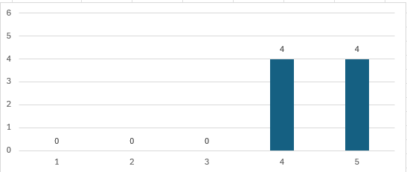
    - I think that I would like to use this system frequently.

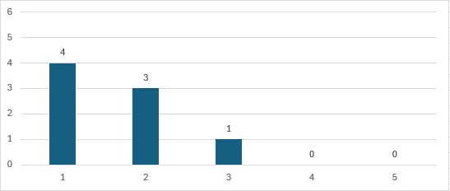
    - I found the system unnecessarily complex.

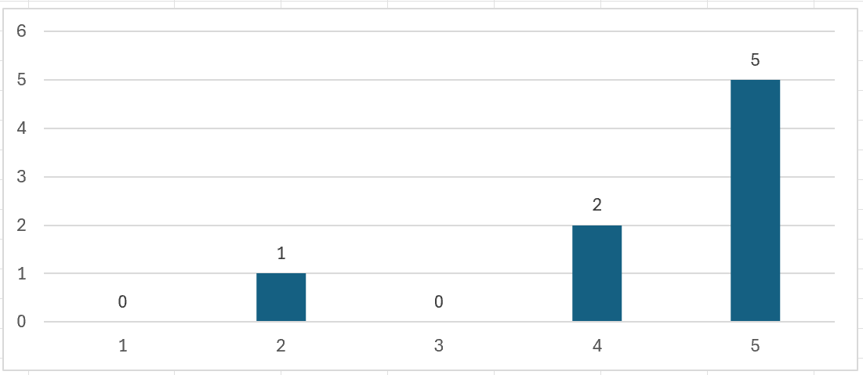
    - I thought the system was easy to use.

    - I think that I would need the support of a technical person to be able to use the system.
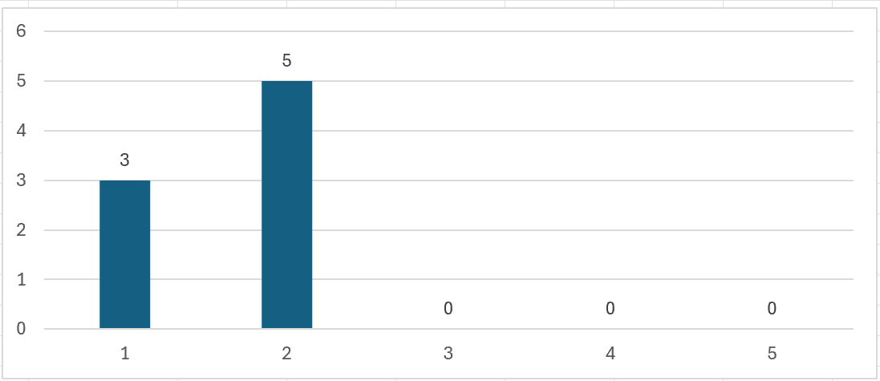
    - I found the various functions in this system were well integrated.
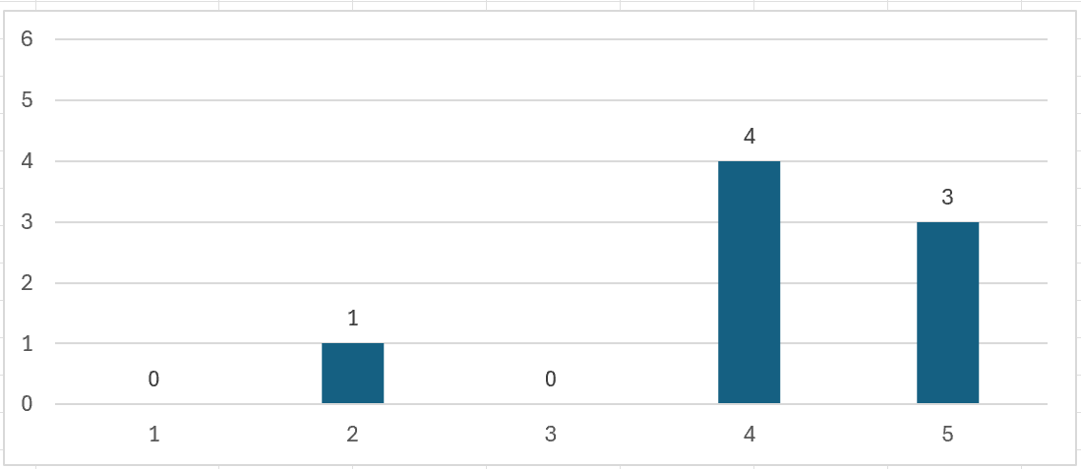

    - I thought there was too much inconsistency in this system.

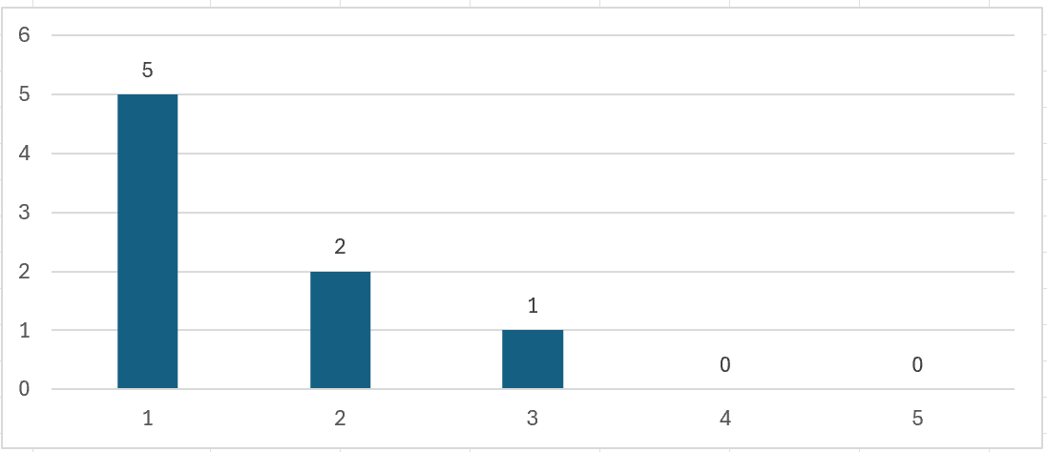

    - I would imagine that most people would learn to use this system very quickly.
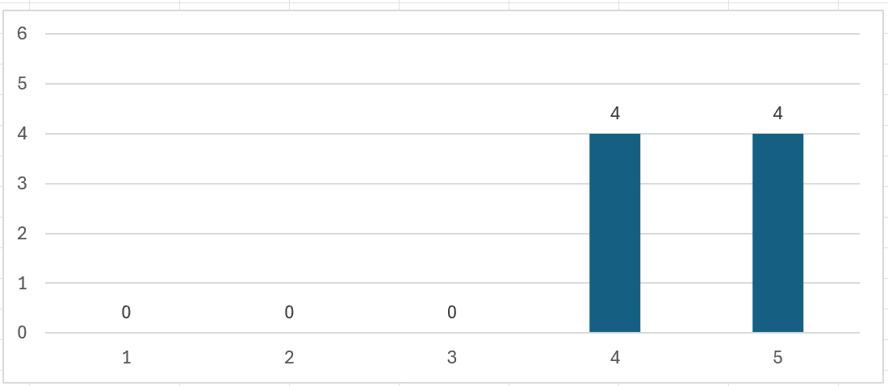
    - I found the system very cumbersome to use.
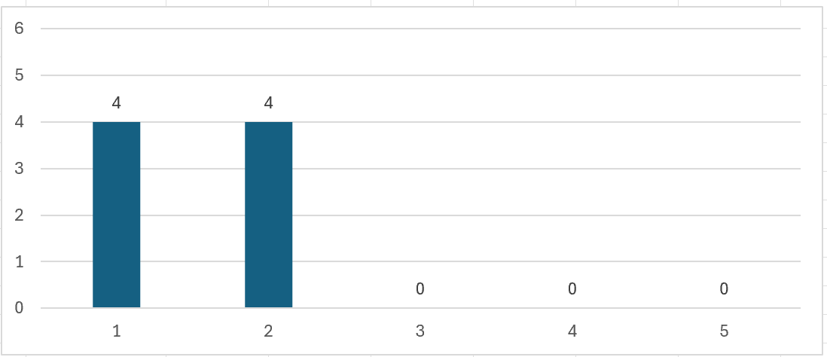

    - I felt very confident using the system.
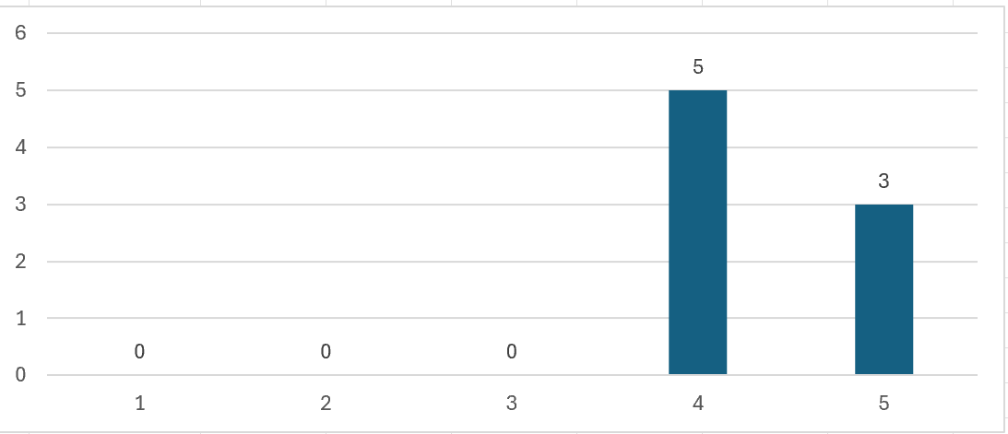

    - I needed to learn a lot of things before I could get going with this system.
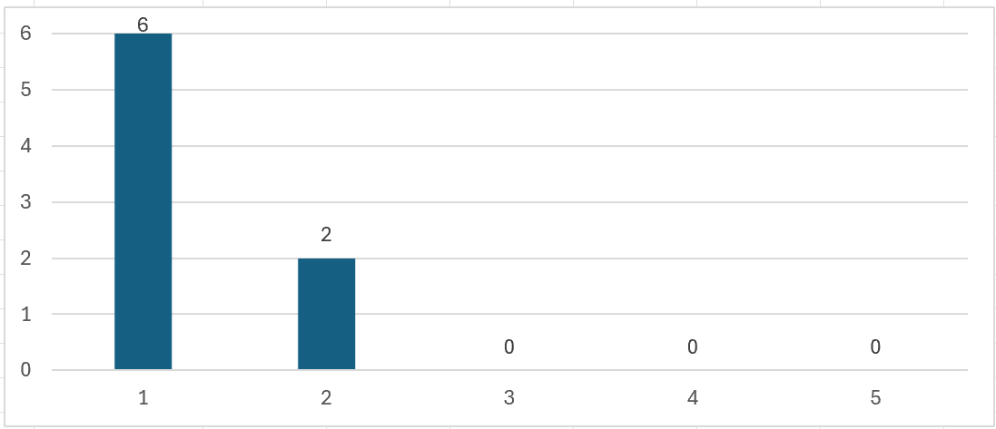
  - Additional questions
Beyond the standardized SUS assessment, we incorporated several system-specific questions that provided deeper insights into our application's performance. These targeted inquiries, while not factored into the formal SUS score, offered valuable qualitative feedback about particular features and functionalities. This approach revealed user preferences and operational needs that might not have emerged through standardized metrics alone, providing essential guidance for future refinements.
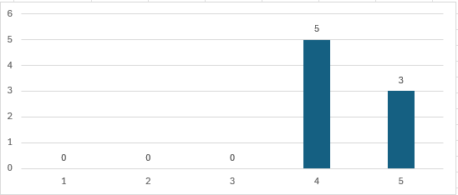
    - The Golan project interface provided clear visualization of data.

    - The workflow in the Golan project matched my expectations.
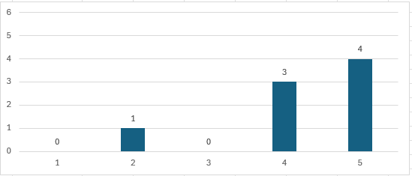
    - I was able to easily find the information I needed within the Golan interface.
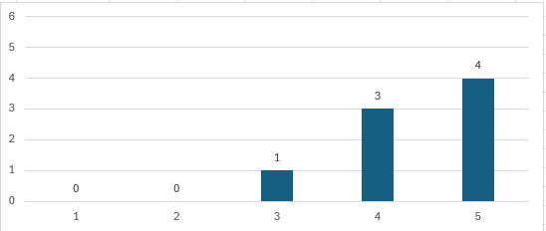

    - The response time of the Golan system was satisfactory.


    - What features did you find most useful in the Golan project? (Open-ended)
In response to the question "What features did you find most useful in the Golan project?", participants highlighted several key aspects. They particularly appreciated the visual representation of graphs, which enhanced data comprehension.
The ability to export reports and community profiles to Excel was identified as a valuable functionality. Users emphasized the system's simplicity and inviting design as significant strengths, along with the capability to share projects with new users.
Additionally, respondents praised the excellent project categorization system, noting that it made it easy to understand where each project belonged within the organizational structure.

    - What aspects of the Golan project could be improved? (Open-ended)
In response to the question "What aspects of the Golan project could be improved?", participants offered several constructive suggestions. They recommended changing the visual representation of funding sources to a different type of graph format.
Users expressed interest in adding a report generator and incorporating more visual data elements throughout the system.
There was feedback about reducing the number of clicks required, with a desire for faster transitions between viewing and editing modes. Participants also suggested enhancing the flexibility and customization options for the summary data graphs. Additionally, they recommended implementing a feature to sort projects by year, which would improve organization and accessibility of historical data.
    - Did you encounter any specific issues or errors while using the system? Please describe. (Open-ended)
In response to the question "Did you encounter any specific issues or errors while using the system?", most participants indicated they did not experience any problems at all with the system. However, one user identified a specific validation issue, noting that they were able to enter an end date that preceded the start date, and the system accepted this illogical input without generating an error message or warning. This observation highlights a potential improvement area for data validation within the date entry functionality.
  - Evaluation summary
The application received positive feedback during council staff meetings, live testing, and through the SUS questionnaire. Mr. Amit Cohen, the General Manager of the Golan Regional Council, expressed enthusiasm about adopting the system as his primary project management tool.
Our SUS score of 85.938 indicates excellent user acceptance, significantly exceeding the industry average of 68. Users praised the visual graphs, Excel export capabilities, intuitive design, and effective project categorization.
Improvement suggestions included enhancing funding source visualizations, adding a report generator, reducing navigation clicks, improving graph customization, and implementing year-based sorting. One user identified a date validation issue where end dates could precede start dates. Mr. Cohen specifically requested additional project sorting filters and expanded export options.
These findings confirm the system meets core requirements while providing clear direction for future enhancements.
- Conclusion and Summary
This paper has presented the Golan Regional Council management application, a system developed to streamline operations and improve interdepartmental communication within the council. The project successfully progressed from conceptual design in Phase A to a functional deployed application in Phase B, demonstrating effective execution and adaptability throughout the development lifecycle. The resulting solution addresses the council's core operational challenges while establishing a foundation for future enhancements.
  - Key Findings and Achievements
- Feature Implementation: The majority of features proposed in the initial meeting with the Golan Regional Council staff, mainly by Mr. Amit Cohen, the General Manager of the council, were successfully implemented, including different ways of sorting projects, a flexibility about what data a user can export and many other features.
- User-Centered Development: By employing a user-centered design approach and integrating feedback from the council staff, we ensured the application met real-world needs.
- Technological Integration: The project successfully integrated a range of modern technologies, including Nest.js for web development,including client and server-side operations, Shadcn/UI and TailwindCSS for frontend components and PostgreSQL for database management.
- Adaptation and Innovation: A notable change from our initial plan was the shift from an application that mainly focuses on village management to an application that manages mainly the projects that are being performed in the council’s jurisdiction, demonstrating our ability to adapt to user needs and leverage existing platforms.
  - Challenges and Solutions
Throughout the development process, we encountered several significant challenges:
- Working with a client - Effective communication with the council staff proved challenging as they were actively managing crisis response during the ongoing war in northern Israel. Their critical responsibilities often limited their availability for project consultations, potentially impacting our development timeline and feature alignment.
Solution - We implemented a more proactive communication strategy by increasing contact frequency and establishing a streamlined communication channel through our designated liaison, Dovrat Marciano. This approach allowed us to efficiently reach necessary stakeholders on a weekly basis, ensuring we could gather essential information and directional guidance despite the challenging circumstances.
- Parallel Development: Working simultaneously on the same code repository presented synchronization challenges, requiring careful coordination and version control management.
Solution: Used Git for version control while we tried to focus on separate branches of the development.
- Storing external files: Managing external documents (Excel, PDF, etc.) presented significant challenges regarding memory consumption and resource allocation, particularly given the anticipated volume of project documentation.
Solution: We implemented an integrated Microsoft Azure storage solution to address these challenges. By establishing a direct connection between our application, database, and Azure's cloud infrastructure, we created a seamless workflow that efficiently handles external files without compromising system performance or increasing local resource demands.
- Cross-device Compatibility: Maintaining a uniform user experience across multiple devices (PC, mobile, tablet, etc…) required careful design and implementation strategies.
Solution: Implemented the Mobile-First design methodology, which prioritizes initial development for smaller screens before scaling up to larger displays. This approach ensured optimal responsiveness across all devices while simplifying the adaptation process for desktop interfaces.
  - Implications and Future Development
The application has significant potential for further development and expansion.
Future research could explore:
- Integrating additional council departments (maintenance, human resources, finance) to create a comprehensive organizational management ecosystem.
- Enhancing data visualization and analytics capabilities to provide deeper insights and support evidence-based decision making.
- Implementing automated reporting systems to streamline documentation requirements and reduce administrative burden.
  - Personal learning Outcomes
This project provided invaluable learning experiences beyond technical skills. We gained significant insights into:
- Effective teamwork under strict deadlines.
- State of the art technologies like Next.js, PostgreSQL and third party authentication.
- Working with a real client to design an application by his requirements.

  - Final Thoughts
We believe the Golan application represents a significant advancement in project and rural management. By combining user-centric design with cutting-edge technology, we’ve created a tool that has the potential to significantly improve the effectiveness of regional council’s staff. The Golan Application is not merely a conceptual model but a fully implemented system ready for deployment. In the immediate future, the Golan Regional Council will transition to using this platform, modernizing their workflows and achieving considerable productivity gains through streamlined digital processes that replace their previous manual methods.
As we approach the official deployment on April 6, 2025, we remain dedicated to refining and optimizing the Golan application. This milestone meeting will mark the formal transition of the system to council ownership, with complete administrative responsibility transferring to their staff. The application not only addresses the council's immediate project and rural management needs but also establishes a robust foundation for future enhancements and expansions of the platform.

References
[1] Cheng, W., Wei, W., & Zhang, F. (2013). Research and Design of Data Integration
Architecture for Rural Planning. Springer Link.
[2] Davydenko, N., Wasilewska, N., Boiko, S., & Wasilewski, M. (2022). Development of
Rural Areas in Ukraine in the Context of Decentralization: An Empirical Study.
ResearchGate.
[3] Glauco, P., Marcelo, J., Andrea, J., Leonardo, A., Fabiola, F., Rejane, F. (2022).
Applying User-Centered Design on Digital Transformation of Public Services: A Case
Study in Brazil. Dl-ACM.
[4] Khomiuk, N., & Pavlikha, N. (2023). Management of sustainable inclusive rural
development projects. Scientific Repository of Lesya Ukrainka Volyn National
University.
[5] Pluto-Kossakowska, J., Fijałkowska, A., Denis, M., Jaroszewicz, J., & Krzysztofowicz,
S. (2022). Dashboard as a Platform for Community Engagement in a City
Development—A Review of Techniques, Tools and Methods. MDPI.
[6] Tomashuk, I. (n.d.). Problems and prospects of management of rural development.
CyberLeninka.
[7] Yudha, E. P., Juanda, B., Kolopaking, L. M., & Kinseng, R. A. (2021). Rural
development policy and strategy in the rural autonomy era. Case study of
Pandeglang Regency - Indonesia. Scientific Scholar.
[8] Zavratnik, V., Kos, A., & Stojmenova Duh, E. (2018). Smart Villages: Comprehensive
Review of Initiatives and Practices. MDPI.
[9] Next.JS Documentation
[10] TypeScript Documentation
[11] Tailwind CSS Documentation
[12] Shadcn UI Documentation
[13] Zustand Documentation
[14] Neon Documentation
[15] Kinde Introduction
[16] PostgreSQL Documentation
[17] Golan Regional Council official website
[18] NPS Score
[19] ChatGPT
[20] Claude AI
[21] v0.dev
[22] Microsoft Azure Blob Storage
[23] Microsoft Azure Communication Services

10. Appendices

10.1. First meeting with the Golan Regional Council board - Summary
Date: 15/07/2024
Participants:
Yaacov Se Lavan - Deputy chairman of the Golan Regional Council.
Muli Shpigel – Director of Engineering Department.
Miki Menahem – Deputy Director of Operations.
Golan Shemesh – Operations Department Manager.
Dovrat Marciano – Development and Strategy Coordinator.
Tal Nadler – Information Systems Manager.
Esti Zisman - Deputy Treasurer of the Council.
Raya David - Project manager in the engineering department.
Naomi Unkelos Shpigel - Project moderator
Eldad Shneor - Software Engineering student
Guy Edri - Software Engineering student
Background and Main Points:
- Currently, the council undertakes numerous projects but lacks a system for planning, monitoring, and displaying data comprehensively. Each village has a dedicated WORD file containing information across various aspects (expansion progress/drainage/sewage/public buildings/sports fields).
- At present, there is no way to view an "overall picture" or retrieve data in preparation for a meeting with the drainage authority.
- Ranking keys are currently being developed to create criteria for each area and assign them relative weight. This work is ongoing and is expected to be completed by September.
- A system for managing and monitoring all projects—there is a need for a system to share information and create prioritization and ongoing monitoring of all processes. This might be implemented in the second phase. We are also considering the integration of Office 365 for task management.
- As part of the collaboration between the academic college and the council, several criteria have been defined that we wish to incorporate into the system being developed by the students, which will serve the council in advancing the Pitaron program.
For this purpose, we have set four goals for this project, which will be presented in the students' project in September (initial implementation as a Working Prototype):
- Update the manual according to the criteria for the Pitaron program.
- Evaluation and measurement of objectives (including progress tracking, graph presentation, and process transparency).
- Aggregation of council information from various sources, enabling the acquisition of government resources and submission of public tenders.
- An interdepartmental interface for all departments, providing the ability to view consolidated information for various entities (Kolhey Golan, Local Economic Corporation, Council).
Tasks to be completed:
- Tal Nadler: Check whether materials can be transferred to the academy in terms of information security.
- Students, Naomi: Take the criteria and integrate them into the system, so they can be presented to us in September, after which we can decide on the next steps (the system is open-source).

10.2. Zoom meeting with Dovrat Marciano, the Golan Regional Council designated liaison – Transcript
Date: 08/08/2024
Participants:
Dovrat Marciano - Development and Strategy Coordinator.
Guy Edri - Software Engineering student.
Eldad Shneor - Software Engineering student.
Eldad Shneor's Meeting
Establishing a Public Infrastructure Management System
Discussion on building a system for managing and documenting public infrastructure, including setting criteria and presenting examples of the user interface.
Presentation of the planned system structure, including types of public infrastructure and the data that will be included. 12:20
Explanation of the five criteria that make up the overall infrastructure score and how they are calculated. 13:43
Presentation of an example table containing various data and scores, and an explanation of how they can be analysed. 15:41
Coordination of a Preparation Meeting for Training Discussion
Discussion on the need to hold a preparation meeting ahead of the training discussion, including confirming participants and coordinating with relevant parties.
Request to hold a preparation meeting with Avital and other people, and obtaining approval from the manager for this. 19:33
Defining Criteria for Ranking Settlements
The need to define clear criteria for ranking settlements according to infrastructure and demographic characteristics in order to set budgetary priorities.
The need to define clear criteria for ranking settlements according to infrastructure and demographic characteristics. 26:12
The idea of defining criteria such as standard size by the number of children and classifying according to gaps between the settlements. 27:18
The possibility of classifying settlements by upper/lower percentile or median, in order to set budgetary priorities. 28:06
Defining Data and Components for the Ranking Table
The need to define the data and components to be included in the ranking table of the settlements, such as demographic data and infrastructure.
The need to define the data to be included in the table, such as the number of residents, settlement clubs, etc. 26:24
The need to define the criteria and how the scores will be calculated for each component in the table. 26:44
The need to define criteria for infrastructure such as internet access, electricity, etc., and decide if there is a need to create them anew. 37:46
The Presented Table for Ranking Settlements
The need to understand the structure and data of the table presented for ranking settlements and decide how to use it optimally.
The table sent by Dovrat is a draft, but it can be used as a basis for work. 29:00
The need to understand if the presented table is the relevant one for work or if a new table needs to be created. 31:40
Suggestion to use the centralized club table as a basis and add the relevant data and criteria to it. 32:10
Work Process on the Ranking Table
The need to define the work process on the ranking table to ensure efficiency and prevent the need for later changes.
Suggestion to work on an initial framework of the table and then add the relevant data and criteria. 32:25
The need to plan the work efficiently to avoid the need for later changes. 33:14
The need to decide whether to present two options for the table to receive feedback and decide on the final version. 36:00
Presentation of Data and the Need for Clear Criteria
The discussion focuses on presenting the existing data and the need to develop clear criteria for ranking the various structures.
Dovrat presents the existing data and notes that they are not sufficiently organized. 40:37
Dovrat explains that she would prefer to present the data in a more organized manner. 41:23
Dovrat suggests calculating scores for each type of structure separately to present the data in a more organized manner. 42:22
Eldad understands Dovrat's idea but notes that there is still a lot of work to develop specific criteria. 45:07
The Need for Developing Criteria and Timelines
The discussion focuses on the need to develop clear criteria for ranking the structures, taking into account the required timelines.
Eldad notes that currently, there are no clear criteria for ranking the specific points, and they will need to develop them. 46:16
Eldad asks if Dovrat can try to create general criteria or if they will need to postpone development until September. 46:56
Dovrat notes that she will work with Yaakov on developing the criteria but emphasizes that they need working time. 47:32
Dovrat suggests working only on what they have now and developing another option later, depending on the feedback. 48:00
Agreement on the Use of Existing Data
The discussion focuses on the agreement to use the existing data, clarifying that they are not final.

